**JOB-AMIGO**

**A Complete Job Portal**

**Kommineni Siva Krishna**

**Thallapalli Ravisha**

**Bandaru Sarath Chandra**

**Yempalla Suresh Reddy**

**Summary:**

For the current iteration we have planned to complete the initial user interface development using Android, Visual Studio and also collection of data and analyze it. We were able to finish the initial screens for the User login, registration, and partial development of user interface and employer interface. We have completed the collection of data from various data resources and will be uploading it into google drive and share the link. Analysis on merging the collected data has also been started and implementing them locally before hosting them to main server allotted for us.

**Framework Specification:**

The framework typically consists of three stages GUI, data collection and parsing, and database. The database will deal with the required data analysis, data storage. The GUI part is being developed in Android. The parser includes the task of sending input to the database in such a way it can understand and analyze the information. And also parser is used to convert the return format of output from database to user format.

**System Architecture:**



The below diagram shows all the sequence operations that takes place in the entire application life cycle.

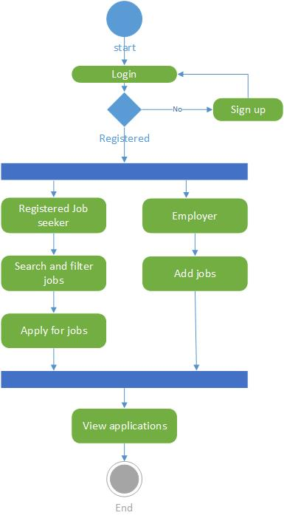

Figure System Architecture

**Domain Model:**

* **Data Sources:**
  + Data is being collected from various web resources and being deployed to google drive for easy access to all team members.
  + We are using some of the existing services related to the job portals like career builder etc...
  + We collect xml data from the available services and parse them to the required format using parsing methods.
* **Methodologies and Algorithms:**
  + For storing the user profile and his history we have used the local sdk database or SQL DB as of now.
  + And the entire front end is developed in Android using ADK and the code for the database connections and other user validations are done using Java.
  + The data that is being collected is in different xml formats. So we are going to parse all the available data and collect only the required format of data. Once the data is being classified we shall further write the code for communication to the user about the jobs based on his user profile.
  + We are using various services that make to search the jobs easier for the user.
  + Some of the sample services are like search jobs, View Applications etc…

**Application Specification:**

* **Software Specification**
  + Tools: Microsoft Visual Studio 2010, Android Development Kit.
  + Operating System: Android
  + Development Operating System: Windows 8
  + Programming Language: Java 7.0.ASP.Net
  + Databases: SQL 2008,SQlite
* **Class Diagram**

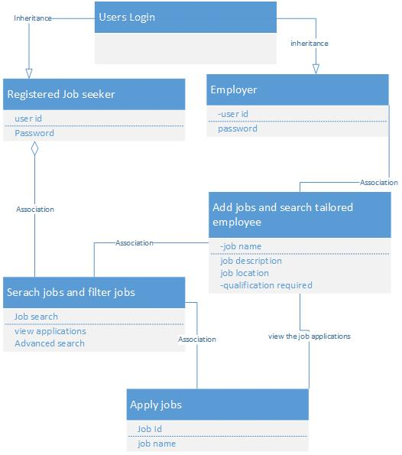

Figure Class Diagram

* + In the above class diagram the implementation of user validation and the employer login has been completed. Currently working on the data analysis part.
* **Activity Diagram:**

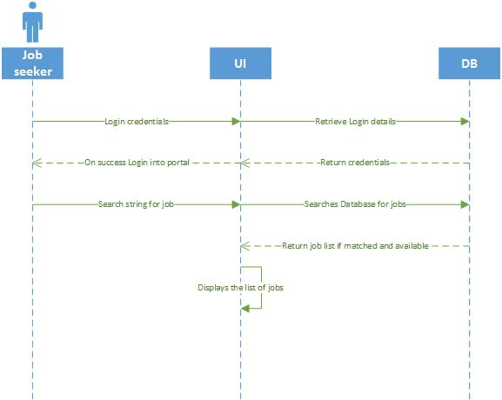

Figure Sequence Activity Diagram

* The service majorly consists of assisting the job seekers in choosing right job. So for an employer the services provided are different. Based on simple search criteria the colleges will be projected to him. But if a user gets registered then there will be jobs notified to him based on his previous search, user profile. The jobs list will classified prior in the database.

The mobile client is entirely developed in Android and it is a native application for android users. The version supports from Froyo to Jellybeans.

**Implementation:**

* **Current Implementation:**

Current implementation includes user authentication and storing of all user related information in database i.e. in a relational database. Data has been collected and being tested on local machines to verify which classification algorithm can be applied. And in how best we can use the API’S to retrieve these required data. The implemented code has been uploaded into GitHub with the current first increment report

The following are the screenshots of user login page, user registration and other registration validations:

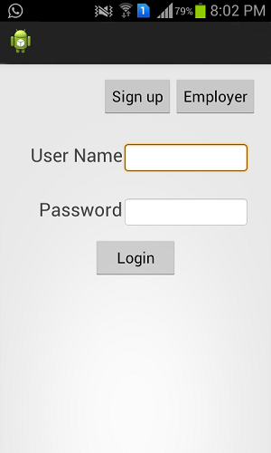

Figure Login page

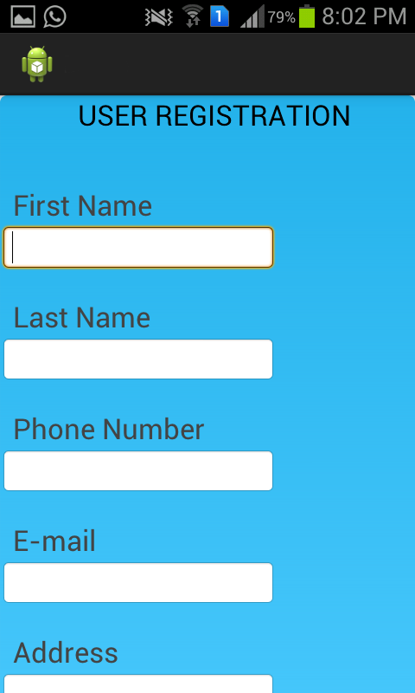 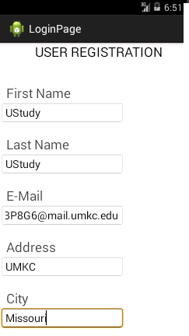

Figure User Registration

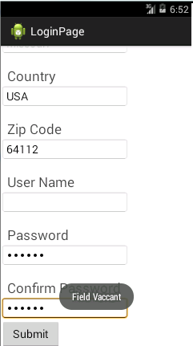 

Figure Projects a message if necessary field is empty

After successful login the above page displays showing the available services that is helpful for the user to proceed in his operations for the job search.

We are currently implementing the services and API’S required for the Job seeker to search the jobs based on his criteria.

**Project Management:**

All the tasks and their day today increments are being updated in the scrumdo.

* <http://www.scrumdo.com/projects/project/job-amigo/summary>

In the first iteration, we have completed the user login and user registration tasks. And also collected the data that is required for the project. So out of 4 we have completed all tasks and only partial amount of work is being forwarded which have been already started.

The work has been equally distributed between the four members of the data with two members dealing with back end and two members dealing with GUI design.

Back End: Siva Krishna Kommineni, Sarath Chandra Bandaru

Front End: Thallapalli Ravisha, Yempalla Suresh Reddy.

**Second Increment:**

The tasks that will be included in second increment will be:

* Completing the entire GUI design with certain animations and color texting – Ravisha
* How to link the data that Is being classified to DB, which parameters to consider and how the indexing to be done for retrieval of data – Siva Krishna
* Testing the available data with certain parameters like salary, Zip code, location on Hadoop and also extracting required data – Suresh
* Data analyzing and classifying the data based on the job seeker search criteria. – Sarath
* Creating the web services for the required functionalities – Sarath & Siva Krishna
* Also using external Databases like SQL server 2008 for storing the history of searches made by registered user and also certain user validations if necessary – Ravisha & Suresh

All the stories with time allocations will be updated in the scrum do for the second phase increment also.